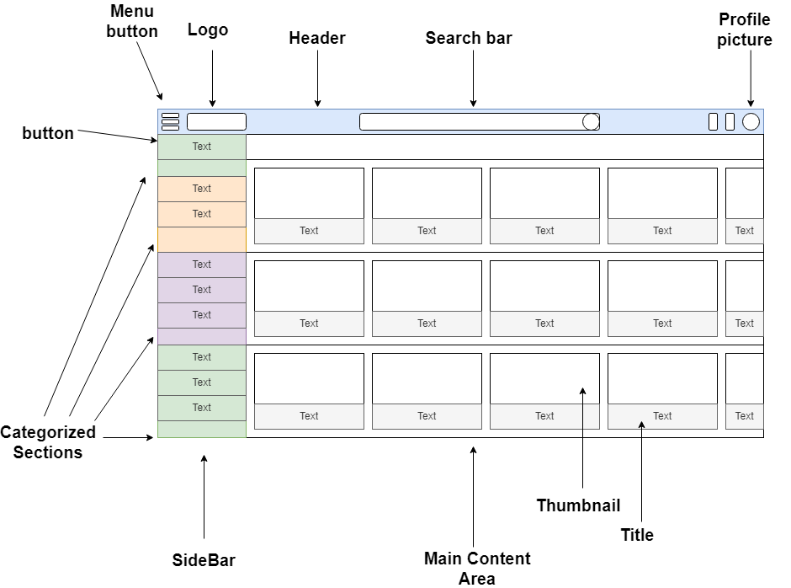

I have chosen Youtube.com as my reference, I approached the layout breakdown by first identifying the most recognizable sections common to the platform. The website interface is organized into three main areas the Header, Sidebar and Main Content Area. By focusing on these large blocks, I maintained a clear hierarchy consistent with YouTube’s user experience design.

I then broke down each section into smaller elements based on YouTube’s familiar features. In the Header, I identified the menu button, search bar, and user profile picture, reflecting YouTube’s focus on personalized user interaction and quick access to account settings. The Sidebar likely includes navigation links for Home, Trending, and Subscriptions, facilitating seamless exploration of different content categories. Finally, the Main Content Area is composed of rows of video thumbnails, organized in a grid layout for efficient content discovery. By analyzing the layout with YouTube’s design principles in mind, I ensured an accurate and functional breakdown of its core components.